WIRELESS SENSOR NETWORKS AND MOBILE COMMUNICATION

PRACTICAL-1

NAME: Neeraj Appari T073

Aim: Understanding the Sensor Node Hardware. (For Eg. Sensors, Nodes (Sensor mote), Base Station, Graphical User Interface.)

Topic: Solar Energy Harvesting for Wireless Sensor Networks

1. Solar energy harvesting that provides an alternative power source for an energy-constrained wireless sensor network (WSN) node.
2. The solar cell performance depends on the intensity of sunlight, where the average power generated by the solar panels is about 220 mW-750 mW.
3. Solar cell efficiency, DC-DC power converters, Maximum Power Point Tracking algorithms, solar energy prediction algorithms, microcontrollers, energy storage (battery/supercapacitor), and various design costs for SEH-WSNs.
4. The polycrystalline solar panel type with size of 180 × 81 × 1.55 mm and 70 × 55 × 3 mm was tested to provide energy supply for the node comprising one microcontroller, Xbee transceiver, and sensor component.
5. The output voltage of solar cell is ranging between 2V-6V.
6. During sunrise and sunset, the sunlight is weak and the incidence angle (θ) is less direct, the power generated is also less.

Benefits:

1. Solar energy is the eternal power source.
2. Solar energy is unpolluted and does not harm the atmosphere.
3. Highest achieved power density 10–15 mW/cm2 as compared to all other renewable
4. Solar energy is flexible, i.e., it can be utilized for low-voltage applications like hand-held calculators, watches, and wireless embedded microcontroller devices as well as high power applications like motor traction, water geysers, power plants, and satellite transponders.

Sensor Node:

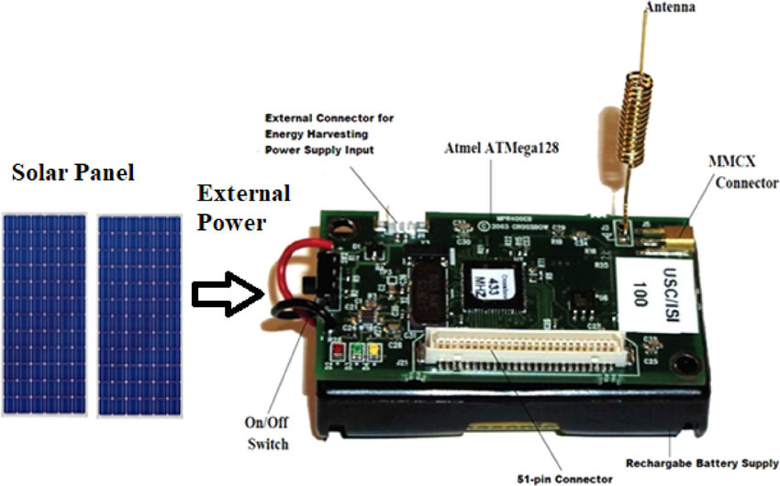

Block Diagram: